To run ‘MATH MAGE’ you must install the ARCADECLASSIC font, pygame and pyglet.

Below is how you could install each of them:

* To install ARCADECLASSIC font:

1. Go to the ‘assets’ folder in ‘Andrew's Checkpoint 1’ folder.
2. Go to the ‘font’ folder.
3. Open ‘ARCADECLASSIC.TTF’.
4. Click ‘install’ to download the font.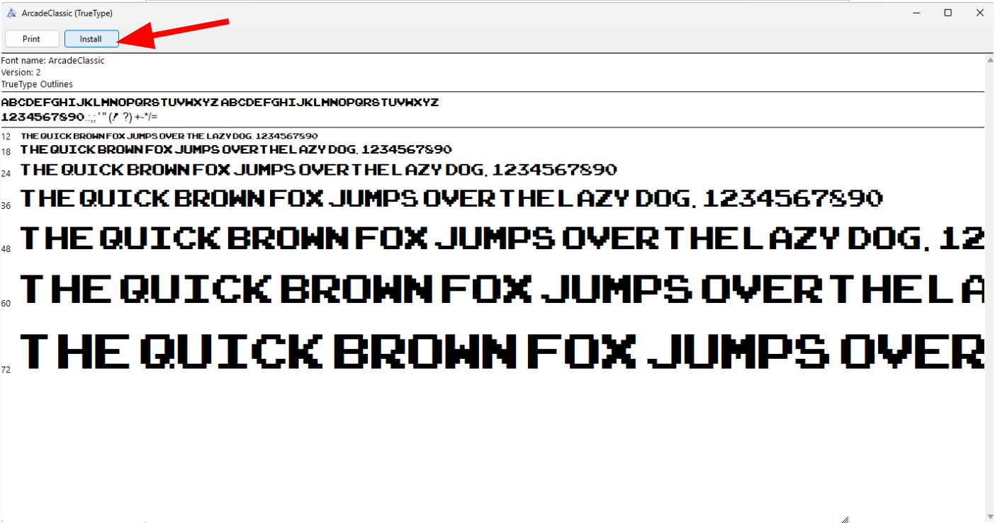

* To install pygame:

1. Open your computer’s Command Prompt by searching and opening ‘Command Prompt’ in your window’s search bar.
2. Copy and paste ‘pip install pygame’ into the Command Prompt.
3. Press enter.
4. Wait for it to finish downloading.

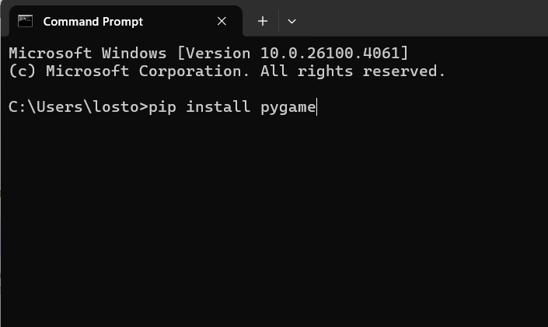

* To install pyglet:

1. Open your computer’s Command Prompt by searching and opening ‘Command Prompt’ in your window’s search bar.
2. Copy and paste ‘pip install pyglet’ into the Command Prompt.
3. Press enter.
4. Wait for it to finish downloading.

